**JAVA PROJECT REPORT**

(Project Term January-May 2023)

## Calculation of BMI(Body Mass Index) into holistic strategy aimed at optimizing overall health and lifespan



Submitted by

**Name: Shaphaba Oinam Registration Number: 12111048**

**Course Code: ..CSE310…**

Under the Guidance of

-Dr. A. Ranjit Kumar (26108)

Associate Professor

# School of Computer Science and Engineering

**DECLARATION**

We hereby declare that the project work entitled (“Title of the project”) is an authentic record of our own work carried out as requirements of Capstone Project for the award of B. Tech degree in Computer Science and Engineering (Program Name) from Lovely Professional University, Phagwara, under the guidance of (Name of Faculty Mentor), during August to November 2022. All the information furnished in this capstone project report is based on our own intensive work and is genuine.

Name of Student: Shaphaba Oinam

Registration Number:12111048

(Signature of Student)

Date:

**INTRODUCTION**

The BMI (Body Mass Index) calculator is to calculate the BMI of a person based on their weight and height. It is widely used as a general indicator of whether a person has a healthy body weight for their height. Specifically, the value obtained from the calculation of BMI issued to categorize whether a person is underweight, normal weight, overweight, or obese depending on what range the value falls between. So our project will help a person to improve their health by following certain workouts or diets according to their BMI.

Our system takes input from the user and then processes the input according to the user’s details and display the result display module.

BMI is a measure of body fat based on a person's weight and height, and it is used to assess the health risks associated with excess body fat.The BMI calculator Java project involves creating a graphical user interface (GUI) that allows users to input their weight and height, and then calculates and displays their BMI.

**PROBLEM STATEMENT**

**Underweight**

* **Family history.** Some people have a naturally low BMI due to physical characteristics that run in their family.
* **A high metabolism.** If a person has a high metabolism, they may not gain much weight even when eating high-energy foods.
* **Frequent physical activity.** Athletes or people who engage in high levels of physical activity, such as runners, may burn significant amounts of calories that result in low body weight.
* **Physical illness or chronic disease.** Some disease types can cause regular nausea, vomiting, and diarrhea, making it difficult to gain weight. Other conditions may decrease a person’s appetite, so they do not feel like eating. Examples include cancer, diabetes, thyroid disorders, and digestive conditions, such as Crohn’s disease or ulcerative colitis.
* **Mental illness.** Poor mental health can affect a person’s ability to eat, including depression, anxiety, obsessive-compulsive disorder (OCD), and eating disorders, such as anorexia and bulimia. Each of these conditions can affect a person’s body image and appetite.

**Obesity**

**Food and activity-** People gain weight when they eat more calories than they burn through activity. This imbalance is the greatest contributor to weight gain.

**Environment-**The world around us influences our ability to maintain a healthy weight. For example:

* Not having area parks, sidewalks, and affordable gyms makes it hard for people to be physically active.
* Oversized food portions increase Americans’ calorie intake, making even more physical activity necessary to maintain a healthy weight.
* Some people don’t have access to supermarkets that sell affordable healthy foods, such as fresh fruits and vegetables.

Food advertising encourages people to buy unhealthy foods, such as high-fat snacks and sugary drinks.[1](https://www.nichd.nih.gov/health/topics/obesity/conditioninfo/cause#f1)

**Genetics-**Research shows that genetics plays a role in obesity. Genes can directly cause obesity in such disorders a Prader-Willi syndrome.

Genes also may contribute to a person’s susceptibility to weight gain. Scientists believe that genes may increase a person’s likelihood of having obesity but that outside factors, such as an abundant food supply or little physical activity, also may be required for a person to have excess weight.[2](https://www.nichd.nih.gov/health/topics/obesity/conditioninfo/cause#f2)

**Health condition and Medication-**Some hormone problems may cause overweight and obesity, such as underactive thyroid, Cushing syndrome and polycystic ovary sundrome.

Certain medicines also may cause weight gain, including some corticosteroids, antidepressants, and seizure medicines.[1](https://www.nichd.nih.gov/health/topics/obesity/conditioninfo/cause#f1)

**Stress, Emotional factor and Poor sleep**-Some people eat more than usual when they are bored, angry, upset, or stressed.

Studies also have found that the less people sleep, the more likely they are to have overweight or obesity. This is partly because hormones that are released during sleep help control appetite and the body’s use of energy.[1](https://www.nichd.nih.gov/health/topics/obesity/conditioninfo/cause#f1)

**PROPOSED TECHNIQUE**

* To solve this unhealthy BMI, we designed a program to calculate BMI and provide tips to keep our BMI in the perfect range.
* In this program, there will be a interface of registering our personal details at first.
* After registering, we will be directed to a interface for entering our height, age, weight, etc. to calculate our BMI.
* The code will be taking the inputs from that interface and will calculate the BMI.
* The formula for BMI calculation is
* We will know our BMI health from this and there will be tips for keeping our BMI in the perfect ratio.

**CODES**

**Welcome page:**

import java.awt.Color;  
import javax.swing.ImageIcon;  
import javax.swing.JFrame;  
import javax.swing.JLabel;  
import java.awt.Font;  
import java.awt.event.ActionEvent;  
import java.awt.event.ActionListener;  
import javax.swing.JButton;  
public class BMICalculator extends JFrame {  
 BMICalculator() {  
 ImageIcon img = new ImageIcon(getClass().getResource("Ss.jpg"));  
 JLabel im = new JLabel(img);  
 im.setBounds(0,0,1200,600);  
 add(im);  
  
 JLabel title = new JLabel("BMI Calculator");  
 title.setBounds(500,100,300,30);  
 title.setFont(new Font("Times New Roman",Font.*BOLD*,30));  
 im.add(title);  
  
 JButton button = new JButton("GO");  
 button.setBounds(500,475,200,50);  
 button.setFont(new Font("Times New Roman",Font.*BOLD*,30));  
 button.setBackground(Color.*pink*);  
 im.add(button);  
  
 button.addActionListener(new ActionListener() {  
 @Override  
 public void actionPerformed(ActionEvent e) {  
 setVisible(false);  
 new Register();  
  
 }  
 });  
 setTitle("Welcome Page");  
 setDefaultCloseOperation(JFrame.*EXIT_ON_CLOSE*);  
 setLayout(null);  
 setSize(1200, 666);  
 setVisible(true);  
 }  
 public static void main(String[] args){  
 new BMICalculator();  
 }  
}

**Register Page:**

import java.awt.*;  
import java.awt.event.ActionEvent;  
import java.awt.event.ActionListener;  
import javax.swing.*;  
  
public class Register extends JFrame {  
 JLabel message;  
 JLabel nameLabel, genderLabel;  
 JTextField nameField;  
 JRadioButton genderMale, genderFemale;  
 ButtonGroup genderGroup;  
 JLabel mailIdLabel, mobileNoLabel;  
 JTextField mailIdField, mobileNoField;  
  
 JLabel lifestyleLabel;  
 JComboBox<String> lifestyleList;  
  
 JButton registerButton;  
 Container cont;  
 JLabel container;  
  
 public Register() {  
 cont = getContentPane();  
 cont.setLayout(null);  
  
 ImageIcon imm = new ImageIcon(getClass().getResource("back.jpg"));  
 container = new JLabel(imm);  
 container.setBounds(0,0,500,515);  
 cont.add(container);  
  
 message = new JLabel("Enter your Details");  
 message.setFont(new Font("Courier", Font.*BOLD*, 20));  
 message.setForeground(Color.*WHITE*);  
  
 nameLabel = new JLabel("Name");  
 nameLabel.setForeground(Color.*WHITE*);  
 nameField = new JTextField();  
 nameField.setBackground(Color.*GRAY*);  
  
 genderLabel = new JLabel("Gender");  
 genderLabel.setForeground(Color.*WHITE*);  
 genderMale = new JRadioButton("Male");  
 genderFemale = new JRadioButton("Female");  
 genderGroup = new ButtonGroup();  
 genderGroup.add(genderMale);  
 genderGroup.add(genderFemale);  
  
  
 mailIdLabel = new JLabel("Mail Id");  
 mailIdLabel.setForeground(Color.*WHITE*);  
 mailIdLabel.setForeground(Color.*WHITE*);  
 mailIdField = new JTextField();  
 mailIdField.setBackground(Color.*GRAY*);  
  
 mobileNoLabel = new JLabel("Mobile No");  
 mobileNoLabel.setForeground(Color.*WHITE*);  
 mobileNoField = new JTextField();  
 mobileNoField.setBackground(Color.*GRAY*);  
  
 lifestyleLabel = new JLabel("Lifestyle");  
 lifestyleLabel.setForeground(Color.*WHITE*);  
 lifestyleList = new JComboBox<String>();  
 lifestyleList.setForeground(Color.*GRAY*);  
 lifestyleList.addItem("Labourer");  
 lifestyleList.addItem("Student");  
 lifestyleList.addItem("Employee");  
  
 registerButton = new JButton("Register");  
 registerButton.setBackground(Color.*GRAY*);  
 registerButton.addActionListener(new ActionListener() {  
 public void actionPerformed(ActionEvent e) {  
 new Calculator();  
 setVisible(false);  
 }  
 });  
  
  
 setBounds();  
 addComponents();  
  
  
 setTitle("Registration Box");  
 setVisible(true);  
 setBounds(500, 100, 500, 515);  
 setDefaultCloseOperation(JFrame.*EXIT_ON_CLOSE*);  
 setResizable(true);  
 }  
  
 public void setBounds() {  
 message.setBounds(150, 10, 600, 30);  
  
 nameLabel.setBounds(70, 60, 100, 30);  
 nameField.setBounds(150, 60, 200, 30);  
  
 genderLabel.setBounds(70, 120, 100, 30);  
 genderMale.setBounds(150, 120, 100, 30);  
 genderFemale.setBounds(150, 145, 100, 30);  
  
 mailIdLabel.setBounds(70, 183, 100, 30);  
 mailIdField.setBounds(150, 183, 200, 30);  
  
 mobileNoLabel.setBounds(70, 240, 100, 30);  
 mobileNoField.setBounds(150, 240, 200, 30);  
  
 lifestyleLabel.setBounds(70, 300, 100, 30);  
 lifestyleList.setBounds(150, 300, 200, 30);  
  
 registerButton.setBounds(150, 360, 200, 30);  
  
 }  
  
 public void addComponents() {  
 container.add(message);  
 container.add(nameLabel);  
 container.add(nameField);  
  
 container.add(genderLabel);  
 container.add(genderMale);  
 container.add(genderFemale);  
  
 container.add(mailIdLabel);  
 container.add(mailIdField);  
  
 container.add(mobileNoLabel);  
 container.add(mobileNoField);  
  
 container.add(lifestyleLabel);  
 container.add(lifestyleList);  
  
 container.add(registerButton);  
 }  
 public static void main(String[] args) {  
 new Register();  
 }  
}

**Calculation Page:**

import java.awt.Color;  
import java.awt.Container;  
import java.awt.Font;  
import java.awt.event.ActionEvent;  
import java.awt.event.ActionListener;  
import javax.swing.*;  
public class Calculator extends JFrame {  
 Calculator() {  
  
 Container conn = getContentPane();  
 conn.setLayout(null);  
  
 JLabel label = new JLabel("BMI CALCULATOR");  
 label.setFont(new Font("Times New Roman", Font.*BOLD*, 25));  
 label.setBounds(50, 20, 300, 30);  
 add(label);  
  
 JLabel age = new JLabel("Age");  
 age.setFont(new Font("Times New Roman", Font.*BOLD*, 18));  
 age.setBounds(50, 70, 100, 30);  
 add(age);  
  
 JTextField agefield = new JTextField();  
 agefield.setBounds(150, 70, 200, 30);  
 add(agefield);  
  
  
 JLabel height = new JLabel("Height");  
 height.setFont(new Font("Times New Roman", Font.*BOLD*, 18));  
 height.setBounds(50, 140, 100, 30);  
 add(height);  
  
 JTextField hField = new JTextField();  
 hField.setBounds(150, 140, 200, 30);  
 add(hField);  
  
 JLabel weight = new JLabel("Weight");  
 weight.setFont(new Font("Times New Roman", Font.*BOLD*, 18));  
 weight.setBounds(50, 210, 100, 30);  
 add(weight);  
  
 JTextField wfield = new JTextField();  
 wfield.setBounds(150, 210, 200, 30);  
 add(wfield);  
  
 JButton b = new JButton("Submit");  
 b.setBounds(90, 260, 200, 30);  
 add(b);  
  
 JButton c = new JButton("Tips");  
 c.setBounds(480, 320, 100, 30);  
 add(c);  
 c.addActionListener(new ActionListener() {  
 public void actionPerformed(ActionEvent e) {  
 new Tipspage();  
 setVisible(false);  
 }  
 });  
  
 JPanel panel = new JPanel();  
 panel.setBackground(new Color(0, 100, 182, 100));  
 panel.setLocation(360, 50);  
 panel.setSize(200, 70);  
 panel.setLayout(null);  
 panel.setBorder(BorderFactory.*createEtchedBorder*(50, Color.*BLACK*, Color.*black*));  
 add(panel);  
 panel.setVisible(false);  
  
 JLabel bmi = new JLabel();  
 bmi.setFont(new Font("Times New Roman", Font.*BOLD*, 18));  
 bmi.setBounds(20, 20, 200, 30);  
 panel.add(bmi);  
  
 ImageIcon Yuo = new ImageIcon(getClass().getResource("Cal.jpg"));  
 JLabel ime = new JLabel(Yuo);  
 ime.setBounds(0,0,600,400);  
 add(ime);  
  
 b.addActionListener(new ActionListener() {  
 public void actionPerformed(ActionEvent e) {  
 double h = Double.*parseDouble*(hField.getText());  
 double w = Double.*parseDouble*(wfield.getText());  
 System.*out*.println(h);  
 double b = w / (h * h);  
 if(b<18){  
 bmi.setText(b+"");  
 bmi.setText(" Underweight\n");  
 panel.setVisible(true);  
 } else if (b>24) {  
 bmi.setText(b+"");  
 bmi.setText(" Obese\n");  
 panel.setVisible(true);  
 }  
 else{  
 bmi.setText(b+"");  
 bmi.setText("Normal\n");  
 panel.setVisible(true);  
 }  
 }  
 });  
 setTitle("Calculator");  
 setLayout(null);  
 setLocation(300, 150);  
 setSize(600, 400);  
 setVisible(true);  
 }  
 public static void main(String[] args) {  
 new Calculator();  
 }  
}

**Tips page:**

import java.awt.*;  
import java.awt.event.ActionEvent;  
import java.awt.event.ActionListener;  
import javax.swing.*;  
  
public class Tipspage extends JFrame {  
 JButton UnderweightButton,OverweightButton;  
 Container cont;  
 JLabel container;  
 JLabel message1;  
 JLabel message2;  
 JLabel message3;  
 JLabel message4;  
  
 public Tipspage() {  
 cont = getContentPane();  
 cont.setLayout(null);  
  
 ImageIcon imm = new ImageIcon(getClass().getResource("back.jpg"));  
 container = new JLabel(imm);  
 container.setBounds(0,0,500,515);  
 cont.add(container);  
  
 message1 = new JLabel("Are you Underweight?");  
 message1.setFont(new Font("Courier", Font.*BOLD*, 30));  
 message1.setForeground(Color.*WHITE*);  
  
 message2 = new JLabel("Well here are some tips");  
 message2.setFont(new Font("Courier", Font.*BOLD*, 30));  
 message2.setForeground(Color.*WHITE*);  
  
 message3 = new JLabel("Are you Overweight?");  
 message3.setFont(new Font("Courier", Font.*BOLD*, 30));  
 message3.setForeground(Color.*WHITE*);  
  
 message4 = new JLabel("Well here are some tips");  
 message4.setFont(new Font("Courier", Font.*BOLD*, 30));  
 message4.setForeground(Color.*WHITE*);  
  
 UnderweightButton = new JButton("Underweight");  
 UnderweightButton.addActionListener(new ActionListener() {  
 public void actionPerformed(ActionEvent e) {  
 new Underweight();  
 setVisible(false);  
 }  
 });  
  
 OverweightButton = new JButton("Overweight");  
 OverweightButton.addActionListener(new ActionListener() {  
 public void actionPerformed(ActionEvent e) {  
 new OverweightTips();  
 setVisible(false);  
 }  
 });  
  
  
  
 setBounds();  
 addComponents();  
  
 setTitle("TipwayPortal");  
 setVisible(true);  
 setBounds(500, 100, 500, 515);  
 setDefaultCloseOperation(JFrame.*EXIT_ON_CLOSE*);  
 setResizable(true);  
 }  
  
 public void setBounds() {  
  
 message1.setBounds(60, 100, 600, 30);  
 message2.setBounds(60, 140, 600, 30);  
 message3.setBounds(60, 240, 600, 30);  
 message4.setBounds(60, 280, 600, 30);  
 UnderweightButton.setBounds(130, 190, 200, 30);  
 OverweightButton.setBounds(130, 330, 200, 30);  
  
 }  
  
 public void addComponents() {  
 container.add(message1);  
 container.add(message2);  
 container.add(message3);  
 container.add(message4);  
 container.add(UnderweightButton);  
 container.add(OverweightButton);  
 }  
  
 public static void main(String[] args) {  
 new Tipspage();  
 }  
  
}

**Overweight page:**

import java.awt.*;  
import javax.swing.*;  
  
public class OverweightTips extends JFrame {  
 Container cont;  
 JLabel container;  
 JLabel message1;  
 JLabel message2;  
 JLabel message3;  
 JLabel message4;  
  
 public OverweightTips() {  
 cont = getContentPane();  
 cont.setLayout(null);  
  
 ImageIcon imm = new ImageIcon(getClass().getResource("back.jpg"));  
 container = new JLabel(imm);  
 container.setBounds(0,0,500,515);  
 cont.add(container);  
  
 //MESAGES  
  
 message1 = new JLabel("Be in Calorie deficiate");  
 message1.setFont(new Font("Courier", Font.*BOLD*, 30));  
 message1.setForeground(Color.*WHITE*);  
  
 message2 = new JLabel("Walk atleast 10000 steps daily");  
 message2.setFont(new Font("Courier", Font.*BOLD*, 30));  
 message2.setForeground(Color.*WHITE*);  
  
 message3 = new JLabel("Do daily cardio of one hour");  
 message3.setFont(new Font("Courier", Font.*BOLD*, 30));  
 message3.setForeground(Color.*WHITE*);  
  
  
 message4 = new JLabel("Well here are some tips");  
 message4.setFont(new Font("Courier", Font.*BOLD*, 30));  
 message4.setForeground(Color.*WHITE*);  
  
 setBounds();  
 addComponents();  
  
 setTitle("Overweight");  
 setVisible(true);  
 setBounds(500, 100, 500, 515);  
 setDefaultCloseOperation(JFrame.*EXIT_ON_CLOSE*);  
 setResizable(true);  
 }  
  
 public void setBounds() {  
  
 message1.setBounds(50, 100, 600, 30);  
 message2.setBounds(50, 150, 600, 30);  
 message3.setBounds(50, 200, 600, 30);  
 message4.setBounds(50, 250, 600, 30);  
  
 }  
  
 public void addComponents() {  
 container.add(message1);  
 container.add(message2);  
 container.add(message3);  
 container.add(message4);  
 }  
  
 public static void main(String[] args) {  
  
 new OverweightTips();  
 }  
  
}

**Underweight page:**

import java.awt.*;  
import javax.swing.*;  
  
public class Underweight extends JFrame {  
 Container cont;  
 JLabel container;  
 JLabel message1;  
 JLabel message2;  
 JLabel message3;  
 JLabel message4;  
  
 public Underweight() {  
 cont = getContentPane();  
 cont.setLayout(null);  
  
 ImageIcon imm = new ImageIcon(getClass().getResource("back.jpg"));  
 container = new JLabel(imm);  
 container.setBounds(0,0,500,515);  
 cont.add(container);  
  
 message1 = new JLabel("Be in Calorie Surplus");  
 message1.setFont(new Font("Courier",Font.*BOLD*, 30));  
 message1.setForeground(Color.*WHITE*);  
  
 message2 = new JLabel("Start lifting Weights");  
 message2.setFont(new Font("Courier", Font.*BOLD*, 30));  
 message2.setForeground(Color.*WHITE*);  
  
 message3 = new JLabel("Eat atleast six meals a day");  
 message3.setFont(new Font("Courier", Font.*BOLD*, 30));  
 message3.setForeground(Color.*WHITE*);  
  
  
 message4 = new JLabel("Well here are some tips");  
 message4.setFont(new Font("Courier", Font.*BOLD*, 30));  
 message4.setForeground(Color.*WHITE*);  
  
 setBounds();  
 addComponents();  
  
 setTitle("Underweight");  
 setVisible(true);  
 setBounds(500, 100, 500, 400);  
 setDefaultCloseOperation(JFrame.*EXIT_ON_CLOSE*);  
 setResizable(true);  
 }  
  
 public void setBounds() {  
  
 message1.setBounds(50, 100, 600, 30);  
 message2.setBounds(50, 150, 600, 30);  
 message3.setBounds(50, 205, 600, 30);  
 message4.setBounds(50, 250, 600, 30);  
  
 }  
  
 public void addComponents() {  
 container.add(message1);  
 container.add(message2);  
 container.add(message3);  
 container.add(message4);  
 }  
  
 public static void main(String[] args) {  
 new Underweight();  
 }  
  
}

**OUTPUTS**

**Welcome page:**

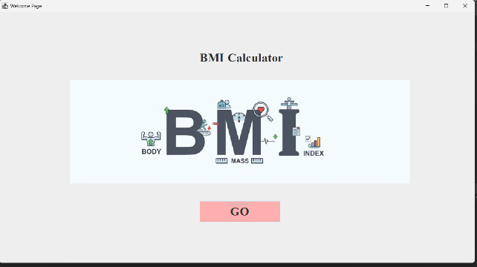

**Register Page:**

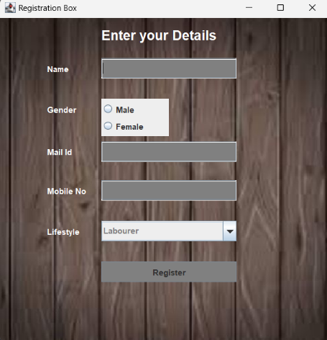

**Calculation Page:**

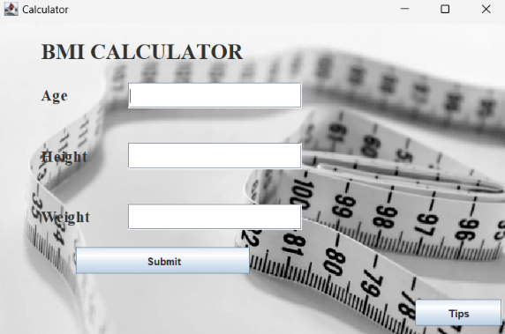

**Tips page:**

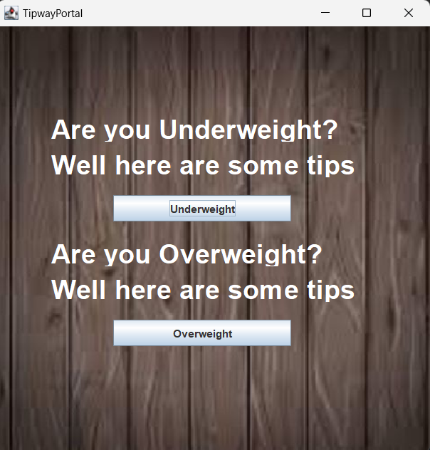

**Overweight page:**

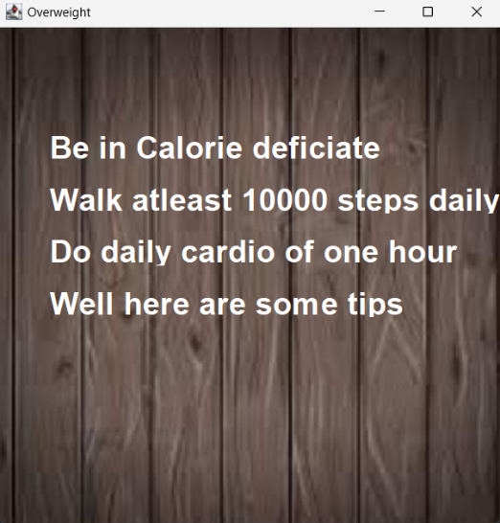

**Underweight page:**

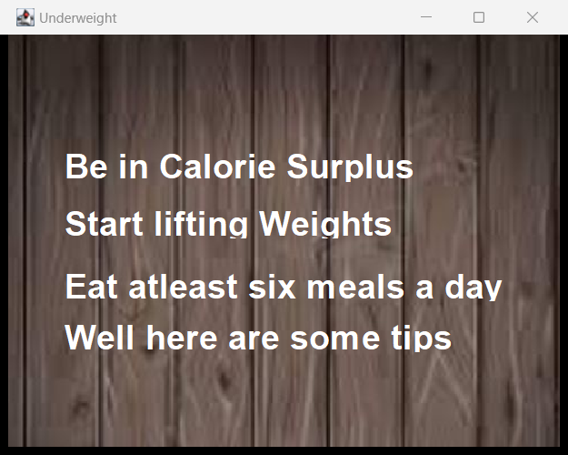

**CONCLUSION**

A BMI calculator implemented in Java can be a useful tool to calculate an individual's body mass index based on their height and weight inputs. The project can involve creating a user-friendly interface for data input and output, implementing the BMI formula in Java code, and handling potential errors or invalid inputs.

When developing a BMI calculator project, it is important to consider the limitations of the BMI metric itself, as it doesn't account for factors such as muscle mass, bone density, or body composition. Additionally, the project provide users with more information, such as healthy weight ranges or recommendations for maintaining a healthy weight through exercise and diet.